Chapter 11, Solution 94


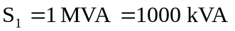
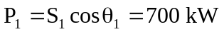
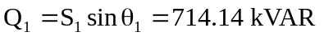

For improved pf,
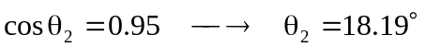
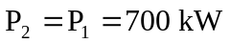
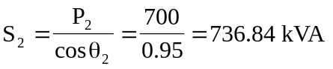
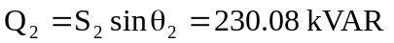

Q₂
Q_{c}

Q₁
S₁
S₂
₁
₂
P₁ = P₂ = 700 kW

- Reactive power across the capacitor

Cost of installing capacitors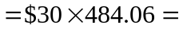

- Substation capacity released 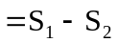
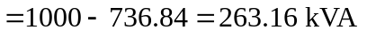

Saving in cost of substation and distribution facilities
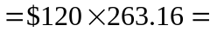

- Yes, because (a) is greater than (b). Additional system capacity obtained by using capacitors costs only 46% as much as new substation and distribution facilities.

